CARRIER NAME: AMERIGROUP(also known as WELLPOINT)

CARRIER CODE: MC010- (EBC AM076)
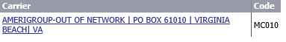

We DO NOT accept Amerigroup OR Wellpoint insurance*
*Please do not schedule any appointments unless there is an existing out of network authorization. For case by case exceptions, Please reach out to our billing team.

