
Worker Comp WC/Auto Accident MVA
SCHEDULING:
Workers Comp (WC):
With Representative: Can schedule next available.
Without Representative:
Obtain all Claim information
Insurance name
Claim#
Date of Injury/accident
Adjusters name, telephone and ext (if applicable)
X-rays can be scheduled without authorization.
MRI, CT, NM can be scheduled 10 business days out.
Patient must be advised to call the third party with appointment details and/or you can
transfer the patient. See OCM and Carisk master list to determine which to provide.
OCM: 1-800-872-2875
Carisk: 1-973-451-9415
FIRST MANAGED CARE OPTION (FIRST MCO, FMCO) DOES NOT NEED TO SCHEDULE THROUGH OCM
Borgata WC can be scheduled for x-rays WITHOUT a Claim number- goes under OCM for insurance carrier

Auto Accident (MVA):
With Representative: Can schedule next available.

Without Representative:
Obtain all Claim information.
Obtain all Claim information
Insurance name
Claim#
Date of Injury/accident
Adjusters name, telephone and ext (if applicable)
X-rays can be scheduled without authorization.
- Must have Primary Insurance Information
MRI, CT, NM can be scheduled 10 business days out.
- Carrier Must Fall on Carisk List (Billing Folder - OP Guide Carisk)
**EXCEPTION* Can be scheduled next available within 10 days of the accident. Day of accident is day
1 and includes weekends. All claim/adjuster information must be obtained* *
Patient must be advised to call the third party with appointment details and/or you can
transfer the patient. See OCM and Carisk master list to determine which to provide.
OCM: 1-800-872-2875
Carisk: 1-973-451-9415

One Time Service Agreements: (Billing Folder – OP Guide One Time Agreement)
For insurances that require an OTSA, collect all contact information for the insurance and send an
Email to Billquestions@aminj.com.

- STATS:
  - Do not require Auth within 10 Days
  - E-mail your PARS & Billing Team involved to insure proper authorization, if not an MRI or CT in order to be billed correctly before exam.

Example of the format in the Insurance Field In RIS:
Motor Vehicle (MV)
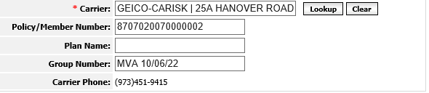

Workers Comp (WC)
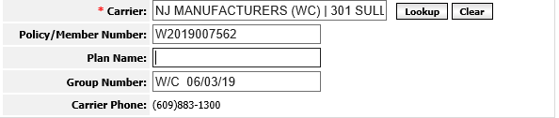

Example of Correct Format in the Order Field:
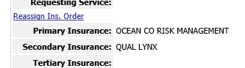

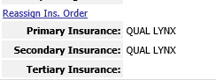

REGISTERING:
MVA
- Patient needs to complete MVA Paperwork
  - Accident Questionnaire
  - Waiver for AIG
  - Assignment of Benefits (OB)
  - Requires Primary Health Insurance as Secondary Insurance
  - Cc One Call Medical on the Order, if necessary

WC
  - Accident Questionnaire
  - Assignment of Benefits (AOB)
  - Cc One Call Medical on the Order, if necessary
  - No Primary Health Insurance required Secondary Insurance

- Receptionist completes Accident Questionnaire with Insurance Field in RIS and have patient complete in its entirety then patient signs.
OR
- Receptionist verifies on the form matches what is in the Insurance Field in RIS, when patient completes.
Ensure that correct carrier code and accident date format:
( i.e. MVA 01/01/11 or WC 01/01/11) is being used during registration.

MVA
- Patient should present Primary Insurance Card on DOS, if pt refuses at the front desk, we are still continuing with the study given all MVA claim info is provided.
- X- Rays Only
  - Do Not require authorization for MVA/WC prior to being seen
  - Patient will need to fill out Accident Questionnaire form (attached) in its entirety
  - Please Obtain the Following:
    - Claim #
    - Name of Auto Insurance/Workers Comp Insurance
    - Date of Accident
    - Adjuster Name, Contact Number and Extension
    - Private Medical Insurance Information:
      - If MVA patient, obtain Health Insurance Info if Any
      - IF WC patient, health insurance information is not needed as Workers Comp insurance should be the only insurance for any work-related injuries.
- If WC then patients employers name i.e. Walmart, Borgata etc
- If MVA/WC payer is listed under OCM then we will need to obtain OCM scheduling authorization form but these patients should never be turned away. Our front desk team/FD Leads can call OCM (800) 872-2875 to obtain the scheduling auth form after registration .

- If you have any questions, you can always reach out to our PARS or Billing Team for further assistance.

