
Scheduling Log In:
IT Sets Up Bria
Click on Icon
User Name: (Provided by IT)
Password: (Create)
Click on Call Center Agent Icon
Type in Information provided by IT
Password: welcome
Phone # (# you are where you are sitting)

Bria and Call Center Contact Agent Work Flow
In order to send and received calls you will need to log in to two applications, Bria and Contact Center Agent
The first application will be, what is referred to as the “Soft Phone” Application, called Bria
- Launch Bria
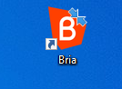
- Log in to the Bria Application
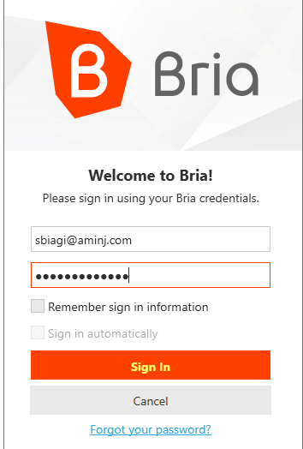

Once logged in to Bria you will need to set your preferred account for calls, this will be the Telex option.
- In Bria navigate to upper left-hand corner to Outgoing Account and click on
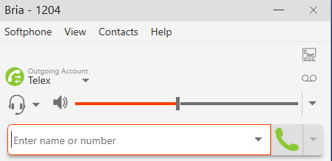

- When the below window pops up select Account Settings
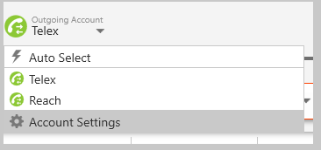

- You will need to ensure both boxes are checked next to Telex and Reach with a check mark and then navigate to bottom of the window to ensure the Preferred account for calls says Telex
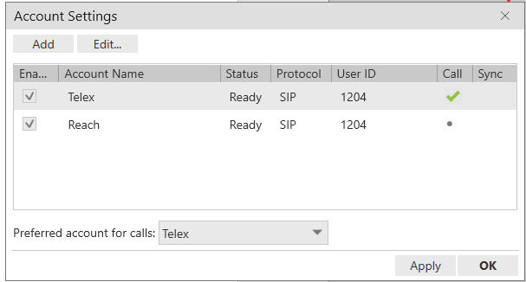

If the preferred account for calls is not set to Telex click on and select Telex in the drop down and click OK

Once you have successfully logged in to Bria you can launch the Contact Center Agent Application
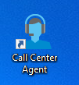
- Launch Contact Center Agent (This replaces REACH)

- The log in screen will pop up and you will need to enter in:
  - Username
  - Password
  - Phone Number- current 4-digit extension
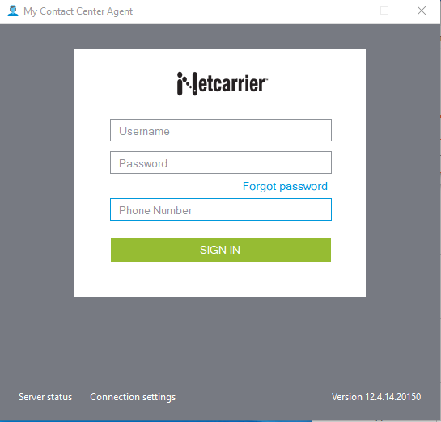

The screen should now display as such with your username in the upper left-hand corner
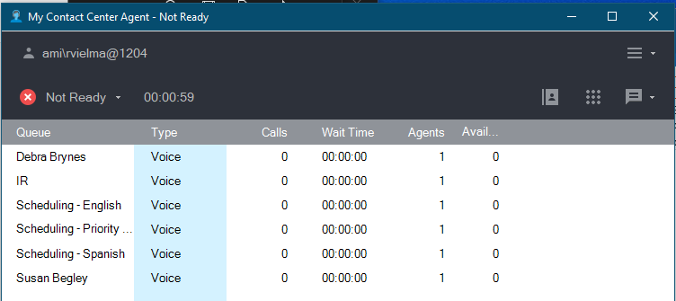

Once logged in to the Contact Center Agent you will need to set your Caller ID and your Status

- Set your Call ID to: AMI Scheduling Team
  - To do so navigate to the upper right-hand corner of the application to the

  - The below window pops up: the first option should be AMI Scheduling Team
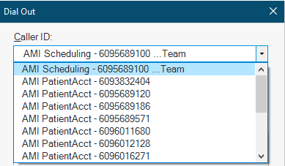

  - Once selected and AMI Scheduling Team displays in the Caller ID field hit Cancel- this will set your Caller ID for future outgoing calls
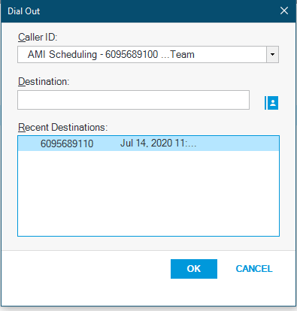

Once logged in to the Contact Center Agent application and you have set your Caller ID information you need to set your status to Available- all agents are defaulted to Not Ready when logging in.
- Navigation to the upper left-hand corner click on next to where is says Not Ready
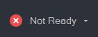
- Once the below window pops up select Available
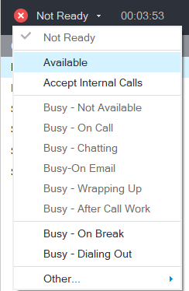

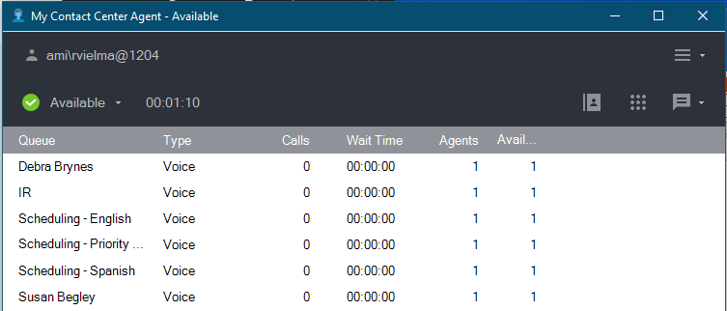
- The screen should display as such with a  next to Available and your assigned Queue listed.

